the first thing we're going to do is have a look at the initialization event. If you remember, the initialization event is the first thing that gets triggered in our program, the first event block.

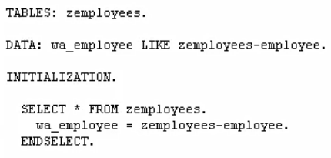



let's say, for our program, we would like to know the last employee number that was used to create an employee record. Now, the initialization event is the ideal place for this type of code. So, we can find out what the last employee number was, and display to the user on the selection screen, so that they know not to select any values greater than that last employee number.